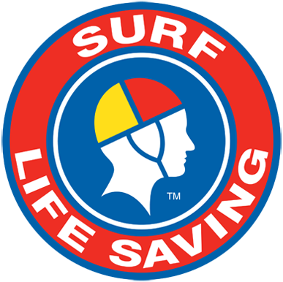
SLSA Leaders’ Masterclass 2019 Multicultural and Indigenous Scholarship
Application form
- Please select from items and print in CAPITALS
- Please attach additional information if space is not sufficient
- Please attach a current CV upon completion of this application form

Privacy:
I have read and understood the SLSA Privacy policy. I understand and agree that it is necessary for SLSA to collect the information that I have provided in this form for selection and to conduct the SLSA Leaders’ Masterclass. I understand that I am able to access my information through SLSA in the event that I need to correct or edit any details, or remove myself from a contact list

General Information
Title | Choose an item. | Name
Date of birth | Click or tap to enter a date. | Gender | Choose an item.
Address |  | Suburb
State | Choose an item. | Postcode
Mobile | Click or tap here to enter text. | Email
Country of birth
Mothers country of birth | Click or tap here to enter text. | Fathers country of birth | Click or tap here to enter text.
Are you of Aboriginal and/or Torres Strait Islander descent? | Choose an item.

Shirt size
Men’s shirt sizes range from S – XXXL and ladies shirt sizes range from 8 – 18.
Men’s | Choose an item. | Ladies | Choose an item.
Do you have any special dietary needs? (please state) ☐

Travel details
Travel to the University of South Australia, Adelaide SA
What mode of transport do you intend to use to get to the program? | Choose an item.
Please complete the following if you are flying:
Which airport will you be required to depart from?

The Graduate Certificate in Business Administration
Graduate Certificate will be delivered online
Do you wish to enrol in the Graduate Certificate? | Choose an item.
Do you wish to apply for a scholarship to assist with the cost of module one? | Choose an item.

Surf Life Saving background
Club name |  | Year joined SLSA
What is your current primary leadership role within Surf Life Saving?

What leadership positions have you held within Surf Life Saving in the last five years?

What single achievement within Surf Life Saving are you really proud of?

What role do you aspire to hold within Surf Life Saving by 2021?

Are you interested in completing the Graduate Certificate of Business Administration?

Other background
Please list any other relevant leadership positions which you have been involved in:

What key issues do you see facing Surf Life Saving (either club/branch/state/national) over the next 3 years?

What do you hope to achieve from this Program?

What do you feel that you can contribute to this Program?

How do you think SLS can better engage with local indigenous and multicultural communities?
Click or tap here to enter text.

How are you going to take your learnings from Masterclass back into your role in Surf Life Saving?
Click or tap here to enter text.

PERSONAL STATEMENT: (max 300 words)
Tell us why you think you should be awarded a Multicultural and Indigenous Scholarship and how it will benefit you and your community. Please also include how you intend to engage and educate your community around Surf Life Saving.
Click or tap here to enter text.

Club Endorsement
Club Name:
Club Contact | Name: | Signature:
 | Position: | Date:
Comments:

Branch Endorsement | (where applicable)
Branch Name:
Branch Contact | Name: | Signature:
 | Position: | Date:
Comments:

State Endorsement
State Name:
State Contact | Name: | Signature:
 | Position: | Date:
Comments:

